**III.Methodology**

**Components:**

1. **MQ135 Gas sensor**

The MQ135 sensor can sense NH3, NOx, alcohol, Benzene, smoke, CO2 and some other gases. It gives the output in form of voltage levels.

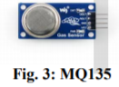

2) **Arduino Uno**

Arduino Uno is a microcontroller board based on the ATmega328P It has 14 digital input/output pins 6 analog inputs, a 16 MHz quartz crystal, a USB Connection, power jack, an ICSP header and a reset button as shown

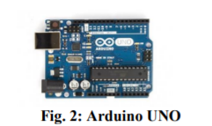

**3)GPRS GSM SIM Module**

Modulates and demodulates the signals from the Wireless Network and allows internet connectivity.

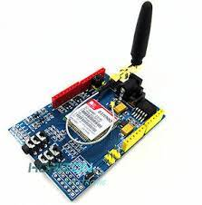

**4)16x2 LCD**

This is a basic (16x2) 16 character by 2 line display. Black text on Green background. It is used to indicate the Air and Humidity in PPM. Fig. 6 shows LCD (16x2).

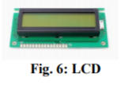

**5) Breadboard**

The purpose of the breadboard is to make quick electrical connections between components- like resistors, LEDs, capacitors, etc- so that you can test your circuit before permanently soldering it together

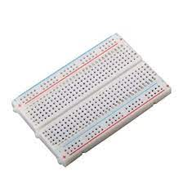

**6) 1K,200 ohm resistors**

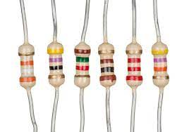

**7) Buzzer**

A Buzzer or beeper is an audio signaling device. Whenever the air pollution goes above the threshold level the Buzzer starts beeping indicating Danger.

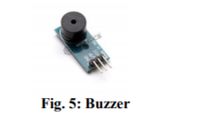

**8) MQ 6 LPG gas sensor**

MQ-6 sensor is a simple-to-use liquefied petroleum gas (LPG) sensor, suitable for sensing LPG (composed of mostly propane and butane) concentrations in the air. The MQ-6 can detect gas concentrations anywhere from 200 to 10000ppm.

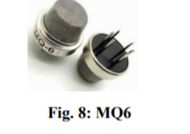

**9) Temperature sensor LM35**

The LM35 is precision integrated-circuit temperature sensor, whose output voltage is linearly proportional to the Celsius (Centigrade) temperature. It can be used with single power supplies, or with plus and minus supplies. Fig.9 shows LM35 sensor for Temperature

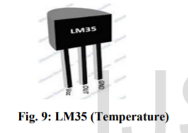

**Software Requirement:-**

**1) Arduino 1.6.13 Software**

**2) Embedded C Language**

**IV.Results and Discussions**

This paper presents the summary of various techniques of air quality monitoring. These techniques are elaborately discussed in the paper

The system to monitor the air of environment using Arduino microcontroller, IOT Technology is proposed to improve quality of air. In factories or high traffic area where the emission is higher and affect many people, in developing countries and in places where the air quality is very poor and can be a health hazard by alerting the people to threatening levels of these realized pollutants.

With the use of IOT technology enhances the process of monitoring various aspects of environment such as air quality monitoring issue proposed in this paper. Here, using the MQ135 and MQ6 gas sensor gives the sense of different type of dangerous gas and arduino is the heart of this project. Which control the entire process.